New Books, Same People, New Readers
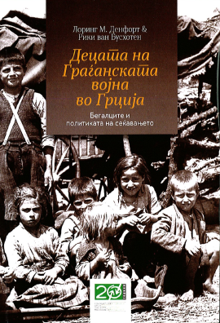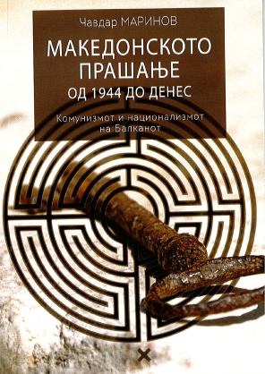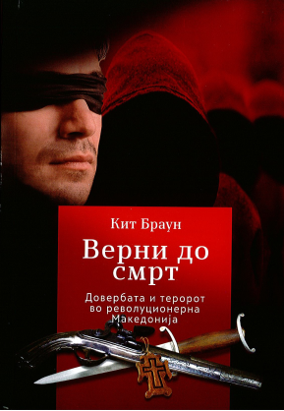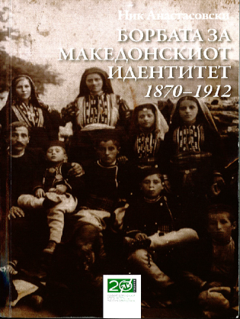
VI.2016

About: “Children of the Greek Civil War, Refugees and the Politics of memory” by Loring M. Danforth and Riki Van Boeschoten; << La question macédonienne de 1944 à nos jours: Communisme et nationalisme dans les Balkans >> , Tchavdar Marinov; “Loyal unto Death, Thrust and Terror in Revolutionary Macedonia” by Keith Brown; “The Contest for Macedonian Identity 1870-1912” by Nick Anastasovski

In the past years few books that should occupy the attention of the academic environment in Macedonia were published under the license of George Soros - Foundation Open Society Macedonia. I am underlining this since the academic part of the Macedonian society reads little the works about its own history, considering it foreign propaganda, thing of the past originating from the cold war. When asked, the academics usually say that they would read about this if something was ever published in the Western Societies - the highly desired destination of this small Balkan nation. The predominating notion here about this is that the problems of this poor and troubled region of Europe was never interesting enough for the western researchers, nor their countries ever really had any interest in investing in a research about this area. But as Macedonia separated from Yugoslavia in the 90’s and the new media Internet appeared, it became clear to the local historians that this impression was wrong. Namely, regarding this, some of the best Universities in the world financed different historical, anthropological or social researches, and many scientific theses were developed under the brand: Balkan or South-Eastern Europe, so to speak. Furthermore it appeared that those materials, as very professional ones, were much in the academic interest of this region or its developing societies. But as they were all protecting their high academic positions obtained in the time of communism, this generation of intellectuals was reluctant to do something more. So, varying from country to country, the intellectuals of this region preferred to stick to something in which they believed was more secure; and that was the same stuff that was obtained during communism. The richer countries such as Slovenia and Croatia caught up more during this useful changing, though most of this “modern” material was already absolved (by these particular countries) even before the change of the system, since they were developing a more liberal academic environment even in the time of Yugoslavia. Nonetheless than they had a more centralized academic environment. Due to this and many other reasons, although the books to which I refer in this article, were published with a very good translation and free of charge (which means that anybody can just take them without paying) they did not acquire the effect that this kind of books usually do, especially in countries like Macedonia - that were longer time in an academic isolation or under ideological control.

“Children of the Greek Civil War, Refugees and the Politics of memory” by Loring M. Danforth and Riki Van Boeschoten (2012)

T
his book is a product of the on-the-field research of the both authors combined with the experience of prof. Van Boeshoten, acquired by his long academic experience in Greece. On-the-field research is acquired mainly by the interviews with the victims and with the refugees from all nationalities (predominantly Greeks, Macedonians and Wallachians), that are realized in many locations. As usually the ones that were dislocated out of Greece were relocated in Eastern Europe, they were controlled by the communist party; the ones that sent their children in the pedo-polices (the boarding-schools formed by her majesty queen Fredericka of Greece) were considered to be with the monarchy. When presenting their work in USA the authors faced certain opposing by some Greek people who claimed that the situation in the “communist boarding-schools and their internment in Eastern Europe” in their research was presented to positive, since they were thinking that the children in those schools were ideologically guided, and the living conditions in them were rather low. The author of the best-seller “Eleni” (this book was sold in 2 million examples and was mentioned by the president Ronald Reagan- who said that “when you read it you really have an impression you are there”) together with some other participants at this presentation later said (and published) that no real discussion was allowed during the presentation. The book “Eleni” is about the mother of the author who in order to save her children, secretly “smuggled” them from the occupied (by the communists) area to the other side, the monarchists. Then the communists shot his mother, together with some others, and threw their bodies in the gorge near the village. This is one of the first direct attestations in this book. The following is about a Greek peasant girl that was from a very poor family. She run away with the communists, first in Albania (where it seems all refugees caught louses), than she went in Poland where she married, and came back to Greece. Another testimony is about a Macedonian girl that went to Hungary. A Hungarian couple wanted to adopt her, but they returned her back to the school, since she didn’t know well Hungarian. Than many years after, an old lady stopped her on the street and asked whether she could live with her since her home was too cold; the old lady said she was the sister of the mother that once wanted to adopt her. She liked to take care for this old lady since she never had mother; when young this refuge wanted to dance twist and dress like the girls that had mothers- with nylon stockings. Then there is a story about a Wallach refugee that went to the pedo-polices, where the children were visited by the queen and her son Konstantinos. Konstantinos wanted to play with him soccer; they started playing but the queen interfered by slapping the boy in the face saying “he was not allowed to play with him”. I think the most important thing that this material contains is the evidence of the lack of human rights in many ways. To mention just few examples for this: some witnesses from the pedo-polices said on TV that they were sexually molested by the teachers; during the night a father makes his young daughter hit a pot that was hanging from a tree so that she will scare the bears; the returning refugees in Greece were repressed on ideological ground of which they were not quite aware of etc. All this proves that this book contains a very professional material on the highest academic level. I would like to add that in many cases the European researches cannot acquire this independent level, since they don’t have as much finances, like this American research did. So usually in the footnote they add the financing foundation, so that the reader would be aware that the research is a “little” sided. Methodologically this book is also very innovative, as Michael Herzfeld from the University of Harvard said: “This extraordinary study opened new horizons in few areas: methodology, style and theme.” I believe the secret of the success of this book is that the authors realized that this is not just a cold anthropological research, but an emotional story about human mystery; the mystery that in this book was eloquently noted by the quote from Luisa Passerini, that “wherever they were all the refugees wanted to visit their birthplace”.

<< La question macédonienne de 1944 à nos jours: Communisme et nationalisme dans les Balkans >> , Tchavdar Marinov (2013)
T
his book deals with the situation of the relationship between Bulgaria and Yugoslavia before and after the separation of the second country from the Eastern block and the position of the Macedonian minority in Bulgaria. This was much a product of the communist system. This system in all countries around the world usually didn’t have enough collective support from its population so that it could maintain its desired power; so usually it sustained it by associating with something else, usually religious fundamentalism or nationalism. According to the data presented, the proportion of this population varied sometimes even approximately 10 or more times. But is seems that this population (the Macedonian minority) became an investment for the bureaucrats from the both countries. The prevailing impression is that when the relationship between the two countries was well, than the situation for the Macedonian minority was good. At the beginning Yugoslavia was sending quality help for this population, but later they begun to send teachers that were suspiciously educated and alcoholics, and were doing scandals with the local population. So bit by bit nobody wanted to associate with them anymore. Than a large investment was acquired in the city of Blagoevgrad (Gorna Djumaja) by which this city became even one of the most modern ones in whole Bulgaria. Later when separating from Yugoslavia (according to this book and many other sources) Bulgaria was the first one to recognize Macedonia, under its constitution name. But the referendum for the independence of this country was somewhat a controversial one, since it included a possibility for uniting with the countries of ex-Yugoslavia. But hence in 1994 all of these countries recognized the Republic of Macedonia under its constitutional name: France, Great Britain, Germany, Italy, Holland and Denmark. This caused anger in the government of Andreas Papandreu, which blocked the border between Macedonia and Greece, demanding compromise for the name of the country. The other interesting analysis is the question of the language. Since Bulgaria didn’t recognize the Macedonian language, Macedonia obtained the recognition by giving up from its minority. All this witnesses the main irony which is so successfully and eloquently presented in this book, and that is that this kind of issues in the Balkan region were used for improving the economy in these countries; developing their infrastructure and urbanization; for academic acquirements and careers and for social and political positioning in the region and the wide world, by obtaining all from the career, financial and political benefits. Everybody somehow wanted to benefit from this situation and looked for its interest. For example during Yugoslavia, Serbia presented its opinion that was that “it was a pity that Yugoslavia and Bulgaria have bad relationship just because of the question of the Macedonian minority”. This highly professional research also is one of the first works that opens the question of the intellectuals in communism. It is no secret that Chinese cultural revolution exterminated the intellectuals, but, in an academic sense, this question was somewhat neglected regarding the situation of the intellectuals in and during communism in Eastern Europe. Undoubtedly communists in both of this countries tended to erase all the intellectuals that were of no interest for the communist party, so almost all the intellectuals that could somehow run away abroad, did so. No serious study for this was ever done for this. The author, Tchavdar Marinov, is a PhD of history and civilizations of Ecole des Hautes Etudes en Sciences Sociales and scientific collaborator of the French school in Athens.

“Loyal unto Death, Thrust and Terror in Revolutionary Macedonia” by Keith Brown (2014)
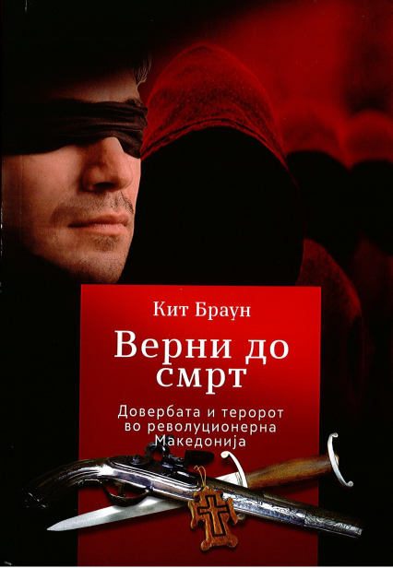
T
his book contains the research which was mainly accomplished in the Pension Fond Folder for the participants in the Ilinden rebellion in the Archive of Macedonia in Skopje. The applicants for this fond were supposed to apply to the then communist authorities, to write what they were doing during this rebellion, and then hope that they will receive something. However as the author said, it is evident that some of them tried to refer to the current political situation, trying to make themselves more ideologically suitable, hoping that this will help them obtain the desired pension. The size of the granted pensions varied so it is possible that the ideological issue influenced not only weather somebody will receive the pension but also how much money they will obtain. The author only mentioned this at the beginning of this book, he did not research this; he focused on the secrecy of the organization that organized this rebellion, the local habits, tradition, heroism or treason; VMRO (Internal Macedonian Revolutionary Organization, in this work noted as MRO, so without the first word) and its relationship with the other ethnic and religious groups. The main objective of this rebellion was to attack against the tyranny of the Ottoman Empery upon the Christians and the poor at the beginning of the 20th century. The main organizer for this kind of “events” and the similar ones was VMRO. However, as it is mentioned by these “participants”, there were also and few much smaller organizations. The vast majority of this rebellion were peasant Christians (but that were also working certain manufacturing jobs or working abroad, for e.g. in Galicia- region in the Austro-Hungarian Empire), while some of its leaders were intellectuals that were studying abroad, mostly in the University of Geneva, where were gathering many supporters for this fight. According to this research two things are becoming clearer: that not only Christians and not only men were the participants. That people from the other religions were becoming part of this shows the initiation ritual that contains cama (kind of dagger) and a gun with a bible beneath (it could be Koran or other holly book); than the aspiring participant with cloth on his/hers eyes puts his hand on this 3 objects and says the oath. Behind him were standing few other members in big red crest; the room during this was very dark, so nobody could see their face. At the beginning usually they didn’t know that they will have to repeat this 2 next times, till they reach the highest level. That a lot of women were active participants is also evident from this research: one woman was hiding the rebels in her house, other was smuggling arms on a donkey, other was bringing them food, opinoks (kind of shoes) and clothes - all this was possible due to the fact that (according to this research) authentic Turks did not attack women, priests or destroying churches. One woman had to marry three times because they killed her previous husbands (and her son) in this fight; other was fashioning their clothes/uniforms in a secretive basement - but it seems there were no woman intellectuals. All of them had to pay the tax to the organization; the richer ones had to pay more. If somebody didn’t want to pay it, than they had particular measures; for e.g. they kidnapped the son of the reach family Vasev in Veles to make them pay. They never robbed the non-Macedonians nor did they ask them any tax. The author also compares the rituals and code of VMRO with the other similar organizations across this planet and its collaboration with them, as the stronger collaboration was acquired with the Armenian one. They were also trying to focus the public opinion around the world on the situation of the Christians in the Ottoman Empery by publishing various magazines across Europe. This book indeed is a “subtle and convincing presentation… that opens up powerful new understanding of the history and the continuing social movements in the region”, as Jane K. Cowan from the University of Sussex stated.

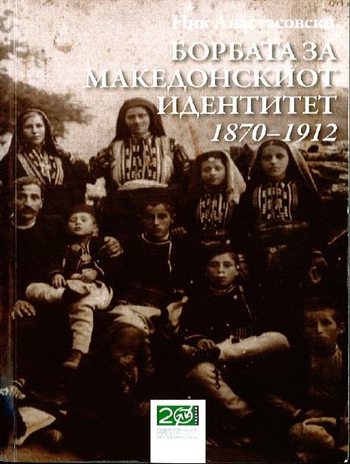
“The Contest for Macedonian Identity 1870-1912” by Nick Anastasovski (2012)

T
his work is a PhD thesis of Mr. Anastasovski that was defended very successfully at the University of Victoria (Australia) in 2006 and later published as book in 2008 by the Pollitecon Publications. This text mainly focuses on the many attempts of the neighboring countries that wanted to benefit from the hard position of Macedonia. Since Macedonia didn’t have its own institutions, the propaganda was going on through the Ottoman institutions. Education was mainly given in the Greek hands. They invested in the Patriarchal schools that were lecturing on Greek language with Greek letters. Later appeared the Bulgarian and the Serb schools that were doing the same or something similar. For e.g. the Serb schools offered to the Macedonian children, beside the education with Serb national identity also free meals and clothes. But since there were not enough teachers even for their own population, these three countries had to take Macedonian teachers, so almost all schools were teaching on Macedonian. Although on this grounds, compared with all neighboring countries, only Bulgaria had more educated population. Valach schools financed by the Romanian government were also established, but they had no political activity, they were just for educating the Valach children. Some catholic and protestant schools were established; their number (according to this research) was very small and they were mainly in the region of Bitola, Gevgelija and Strumica and the southern region of these 3 cities. The institutions were always in favor with the ones that were with the Ottoman authorities. Since the authentic Macedonian church was abolished with stately ordering, the priests continued to ask for justice at the patriarchy in Istanbul, but there they had to claim they were all Greeks. Later similar things happened with the Bulgarian and Serb church. Theodosi Gologanov initiated the idea for unification with the Catholic Church, for which they received positive signs from Rome. They got this idea since obviously nobody from “the other side” would ever recognize the Macedonian church. But this movement was stopped due to the wars that happened in this period. Since centuries ago (while the empery was still tolerant, priest from Ohrid with a help from the Austrian aristocracy initiated buying of arms and help for Christianity - this was stopped by the Empery together with the existence of the Macedonian church) the communication with Europe was stopped, very small part of the notion about how modern institutions should function was present. Some initiatives for institution establishing were done but they were in the manner they used to have those centuries ago: not civil institutions but organized by the church or by VMRO (for e.g. the courts).

Conclusion: I think that these researches are reaching far more intellectual space than stated, since they are reminding us of the rational men whose slavery is to no site (political site, ideological etc.), since he is slave only to the values. I would like to state that there are many reasons why almost nobody read these books; as a consequence of which there were no reviews. I think somebody did everything possible this to be achieved. I will mention just few reasons why I think like this. For e.g. I think that the book << La question macédonienne de 1944 à nos jours: Communisme et nationalisme dans les Balkans >> is printed with really small letters. Than - who would like to read this books whose editor was lustrated as a collaborator of the SS? I used to write (in the past 18 years) many letters of complaint (emails of phone-calls) to the foundation in Budapest where I stated that many people (including me) find the fact that Vladimir Milchin is in it very disturbing. Why for me this is annoying? I will give you just one of the many examples. Because when he expelled me from the University I asked him why? He told me (quote): “Because you cannot put your legs on the same table with me”.

“Macedonian Question from 1944 until Now: Communism and Nationalism on the Balkan” by Tchavdar Marinov (2013)
Patriarchal schools were the schools that were under the Greek Orthodox Church that was at that time leading the patriarchy of all orthodox churches located in Istanbul …………………………………………………………………………………………………………………..

